( 2.1)

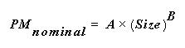

( 2.2)

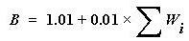

( 2.3)

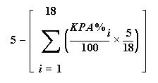

(2.4)

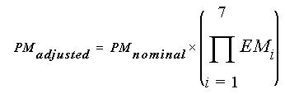

(2.5)

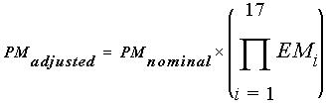

(2.6)

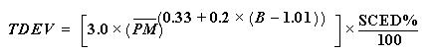

(3.1)

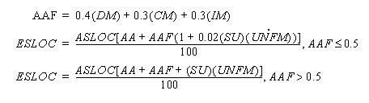

(3.2)

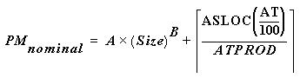

(3.3)

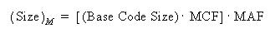

(3.4)

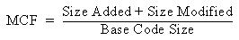

(3.5)

(3.6)

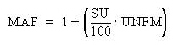

(3.7)

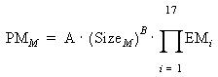

(3.8)

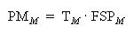

(EQ 1)
